**Scenario-based task**

A new client is sending us a XML for translation into 11 languages. Although your company has translated several types of XML in the past, this one is a little bit tricky. For one thing, the client is asking only for a “partial” translation. Only items whose “name” property is an even number value should be translated. For example, the string with “name=’num6’” needs to be translated, while the string with “name=’num1’” does not.

Here is what the document looks like:

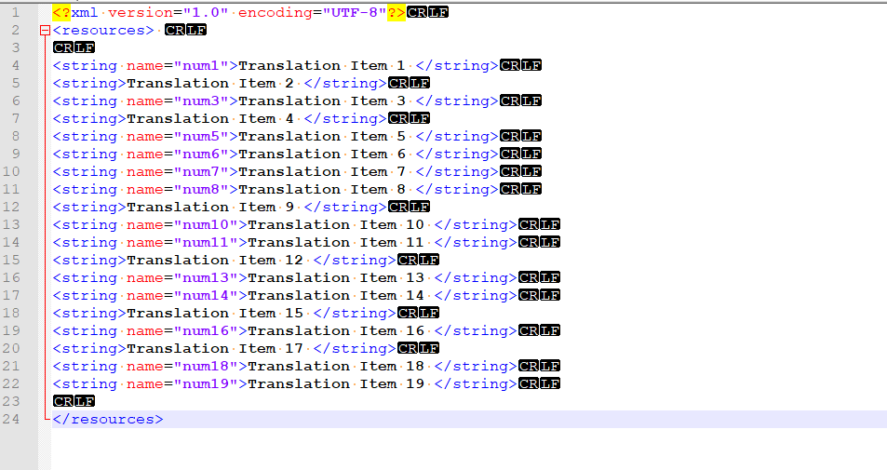

[example.xml](https://drive.google.com/file/d/1OhVaFXMiMtPrCizjorrCyxukfVbfgLhQ/view?usp=sharing)

Your project manager is asking for a solution. Now she is under the impression that she herself must copy and paste all the strings to a spreadsheet, have a linguist translate them, and incorporate them back. But she is not quite happy doing that. She thought this approach would be quite risk-leaning and ineffective. This is a document that has 19 strings for translation, which is fairly easy to handle. But what if sometime in the future the client sends you a document with 190 or even 1900 such strings?

Also, your project manager had a loose memory of how they did things in the past. She told you that the last engineer, who left the company one year ago, used to have a filter set up in the CAT tool that would only import XML items with a “class=’NEED’” property. Any item without the “class=’NEED’” would not be imported. This filter seems to be still functioning well in your CAT tool.

**Task Description:**

1. Prep the document for translation in a CAT-tool WITHOUT manually copying and pasting things around.
2. Regarding what the project manager told you about the old filter, it is your call whether to use it. The project manager thought it might make your work easier, but if you have a better solution surely you can go the other way.
3. After the file prep step, pseudo translate (Or use machine translation) your XML into Traditional Chinese, and generate the result.
4. If you decide to use the old filter, you can skip task 3) because the system itself will take care of the rest.
5. If your solution involves a script/program, feel free to attach.

**Scenario Based Task 2:**

Your company received a request to translate a multilingual spreadsheet with medical device information. At first glance, the spreadsheet seemed to be easy to handle: most strings appeared to be repeating themselves, differing only in number digits that represent measurements.

[Medical labels translation](https://docs.google.com/spreadsheets/d/1dOKCUk3_nYa_UGz0UbVuPeIdmCtqmDLpnYyi6orI3aw/edit?usp=sharing)

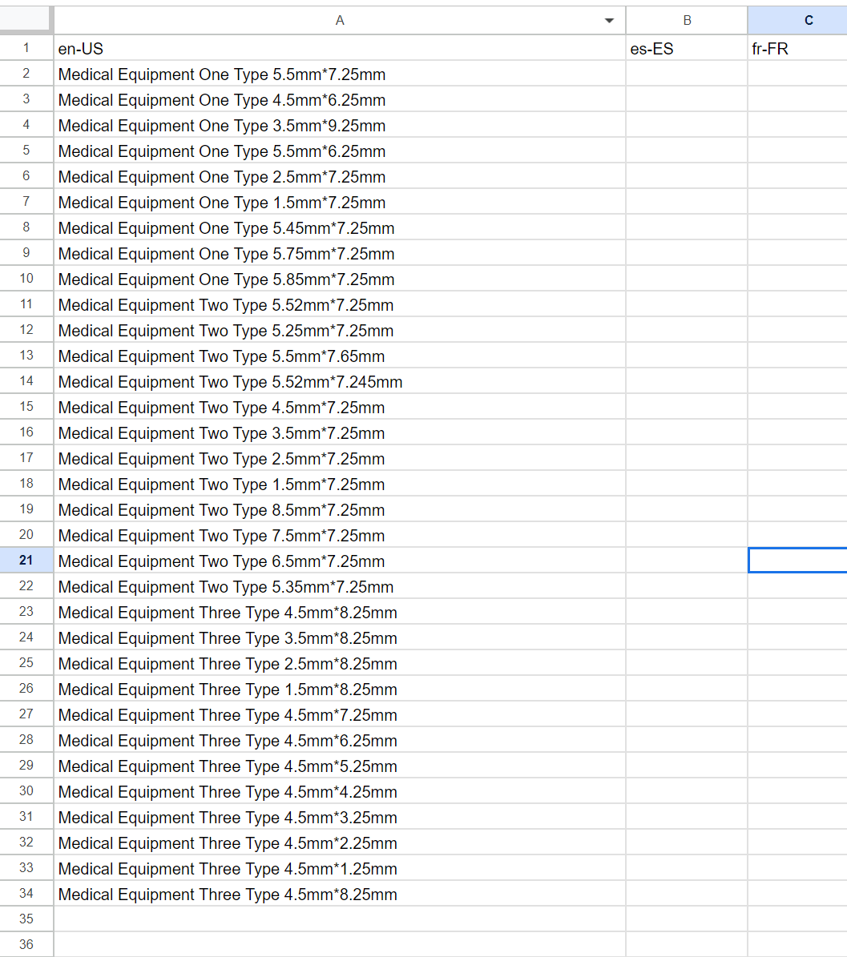

Except, there seemed to be one problem: as your project manager imported this document into the CAT tool for analysis, she noticed that despite such similarities, the CAT tool did not treat them as repetitions or close fuzzy matches - primarily because these strings were too short. This means that in translation, linguists would need to copy and paste the same string a dozen of times and change the measurements manually (also imagine a scenario where there are over a hundred such strings). Also, your project manager would have to charge the client as if all strings were NEW WORDS. Apparently, your client would not be happy about your pricing strategy: after all, most of the strings were quite similar and it wouldn’t be fair for them to pay for the translation of “Medical Equipment One Type” 10 times (if not more).

**Your project manager then asked for your help. Is there a way to reduce the cost of translation?**

Try to design a solution that resolves your project manager’s concern. Attach your prepared/modified source document (if any) and explain your solution.

**File Handling Task:**

Here is the thing. The project manager has been working with a translation vendor agency on a project into 8 languages. Your project manager made it clear that the end delivery format is .docx and should follow a specific folder structure: all documents should retain their original name, but also be placed in a folder named by the language-country code. For example, a file named "fileName.docx" in English should retain its original name, but be placed in a folder named "en-US".

Unfortunately, the translation agency your PM is working with failed to follow these instructions. Instead of putting files in language folders, they attached the language country code at the end of each translated file. For example, fileName.docx is now fileName-en-US.docx. and they sent all files back within a SINGLE folder

As annoyed as your project manager could get, she needed your help on this because she just learnt that this whole translation agency went out of office for the Chinese lunar year, which means it is impossible for her to send the files back to them. With the deadline approaching in 5 to 6 hours, and given that there are 20+ files into 8 languages (which put the total file count at 160+), manually renaming files and organizing them into different folders has become an impossible task.

**Task Description:**

Design a solution that reverts the file names back into its original format, and organize the files in the desired folder structure.

If your solution is a script or a program, feel free to attach it.